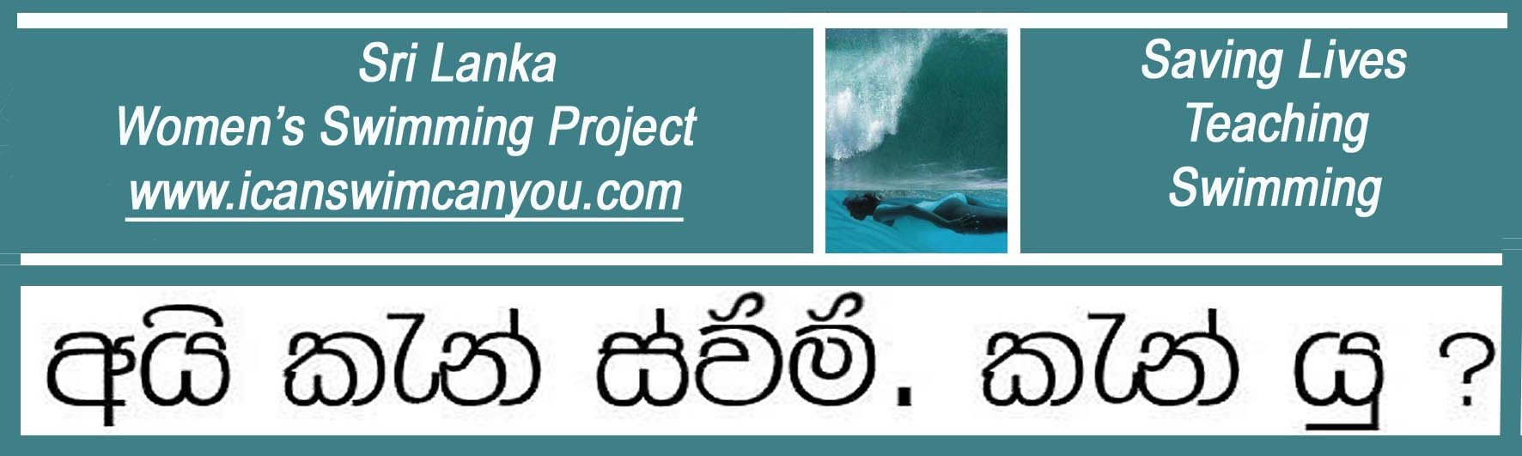
A United Kingdom Registered Charity No. 1129236 www.charity-commission.gov.uk/Showcharity/

September 2011 Latest News

Drowning Prevention Conference in Dublin

As the Lifesaving Foundation of Ireland are our major supporters in Sri Lanka, it is always a delight to attend their Drowning Prevention Conference in Dublin and hear completely different perspectives from around the world focus on a wide range of issues, such as how the building a new bridge over a river led to an increase in suicides between 11pm and 2am, or how damming up a small fordable stream to provide much needed irrigation water in Africa created a drowning hazard for the inhabitants on either bank and a public safety problem for overloaded and unsuitable boats used to make the crossing. Equally interesting was a forensic dissertation from Finland on how diatoms, those microscopic creatures whose amazing shells lay down chalk over millions of years, also turn up in the body tissues of those who drown. On a more cheerful note, the lively exchange of ideas on different teaching techniques to reduce drowning provided encouragement to our belief that the ability float and breathe is the key to a safe and stress-free start to learning to swim and swimming well.

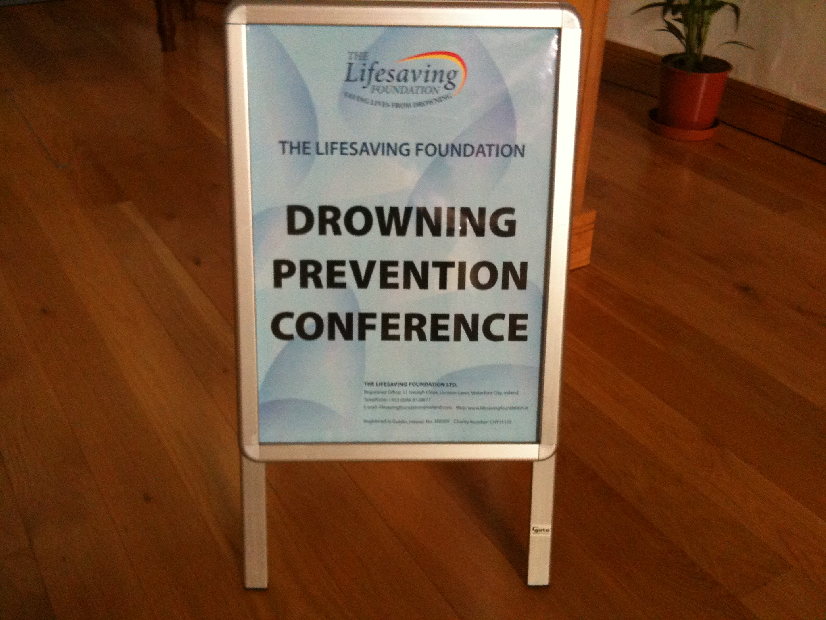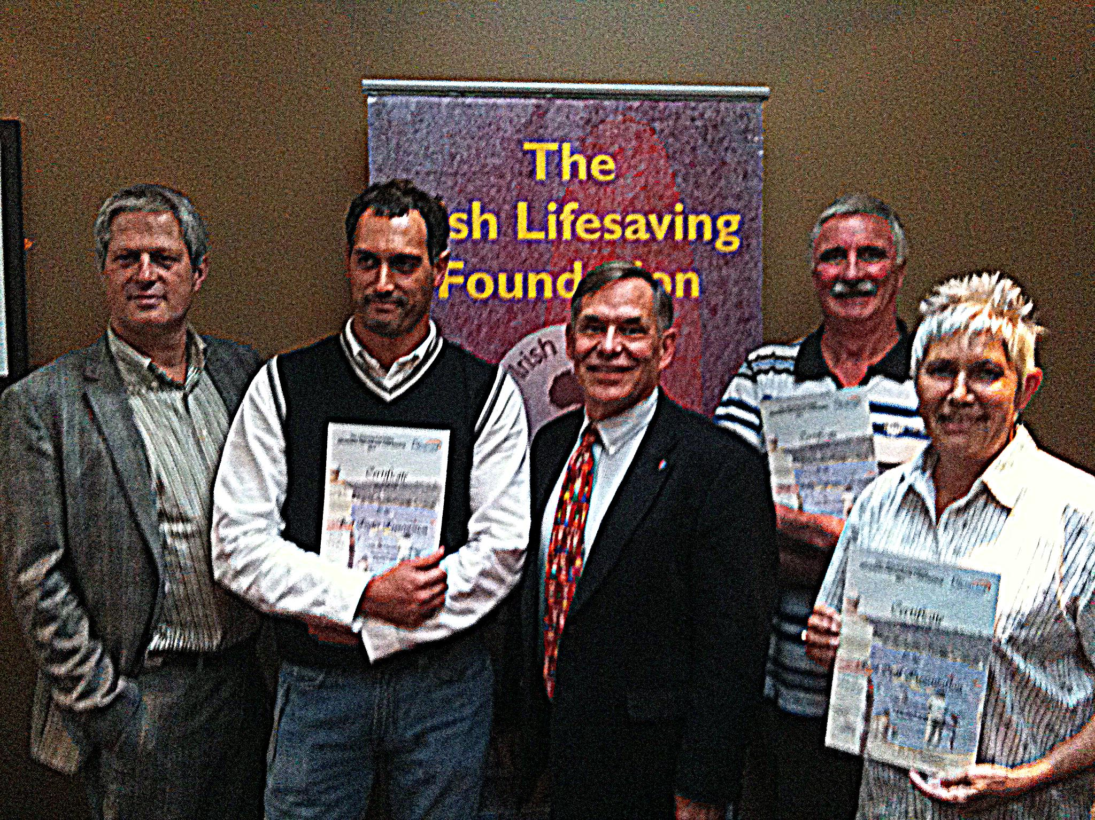

Meeting of Minds. Speakers, academics and specialists from around the world share a common goal to reduce global drowning: Left-to right: Dr Joost Bierens from the Netherlands, Dr Statis Avramidis from Greece, Professor Stephen Langendorfer from the United States and Dr Kevin Moran from New Zealand join Christina from Sri Lanka to congratulate her for the award of Best Speaker.

Michael Fonfe’

