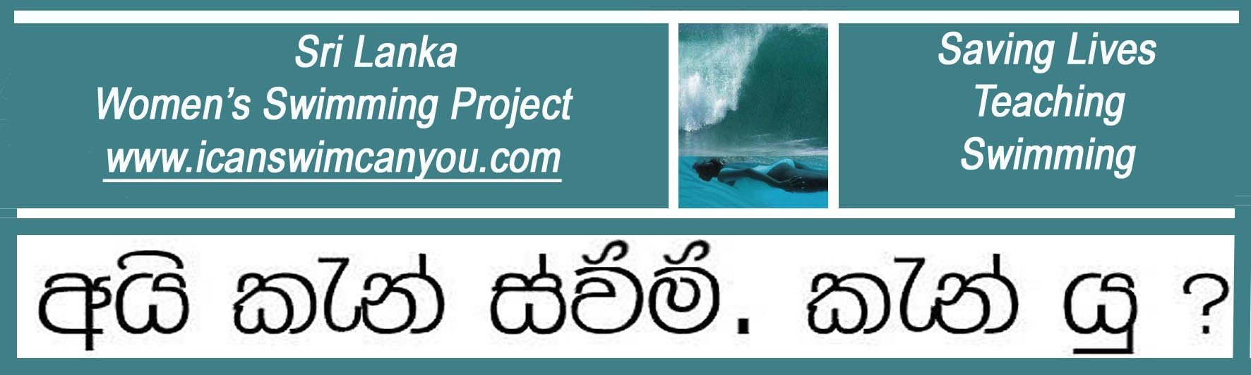
A United Kingdom Registered Charity No. 1129236 www.charity-commission.gov.uk/Showcharity/

February 2012 Latest News

Latest Crop of Swimming Teachers Move up a Professional Level

Many thanks to the UK Swimming Teachers Association Chief Executive, Roger Millward, for authorizing Christina to run a special overseas Level Two Swimming Teachers Course at Habaraduwa for two of the Project’s longest serving swimming teachers.

Dinusha joined the Project in 2006 and, at the age of 14. With her amazing grasp of English, Dinusha quickly established herself as the principal translator. Along with her older sister, Umesha, who has since gone on to university in Australia, these two girls held the Project together for two years whilst Christina underwent treatment for cancer. It is extremely pleasing that Dinushsa should now proceed formally up to the next level of teaching swimming. Unlike a UK teacher, who would normally teach classes of children, Dinusha has been teaching adult women and teenage girls on a one-to-one basis for most of her six year teaching career. She also closely follows Christina’s technique, which is to teach and get students to find and balance their natural buoyancy first so that they can float breathe freely at all times and then introduce propulsion. Dinusha has taught hundreds of women to swim and we look forward to advancing her career further.

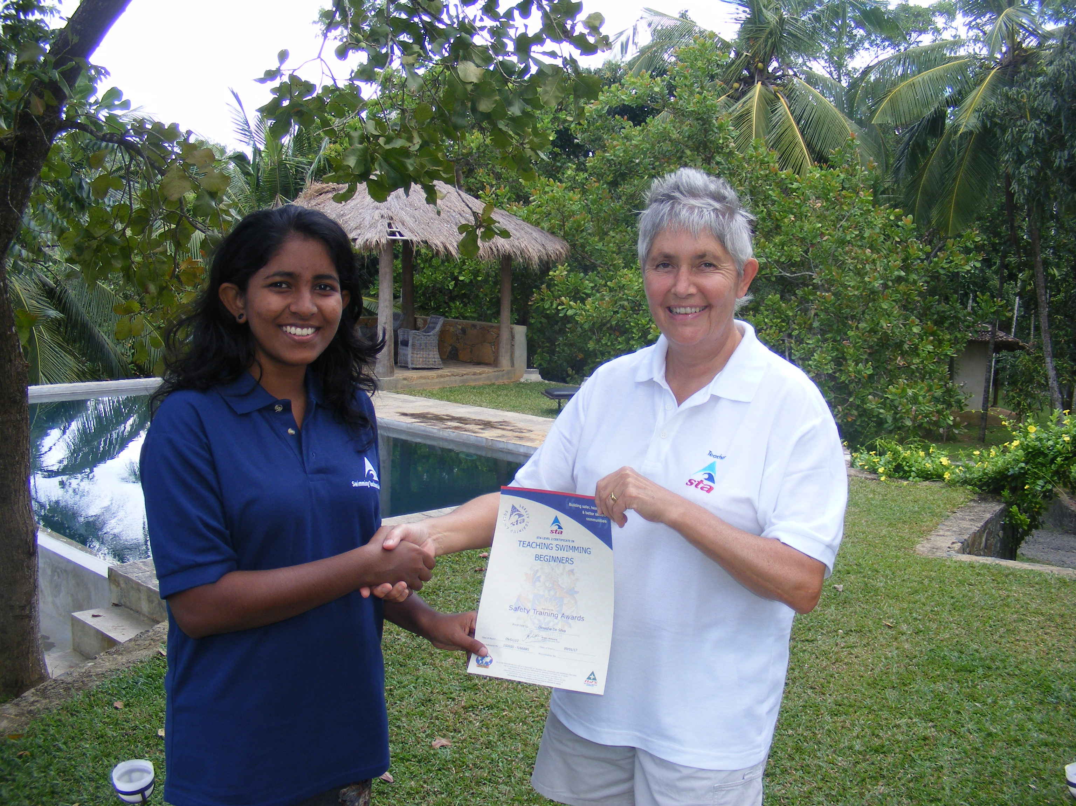

Congratulations to Dinusha, seen here accepting her UK STA Beginner Teacher Certificate from Christina.. The Project’s current teaching pool can just be seen in the background.

The other newly qualified swimming teacher is Sanduni who, like Dinusha, is a Founder Swimmer of the Project. Sanduni distinguished herself as a natural sportswoman and leader from her earliest days of learning to swim, formally qualifying as a Student Swimming Teacher with Dinusha. She has never looked back and went on to become Head Coach of Junior Swimmers at the Colombo swimming school of Sri Lanka’s own Olympic swimmer, Julian Bolling, who follows Australian swimming teaching methods. In Colombo, Sanduni was a popular teacher much in demand by parents to teach their children. As a result, Sanduni’s career development has been more conventional, as it were, teaching more children than adults to swim.

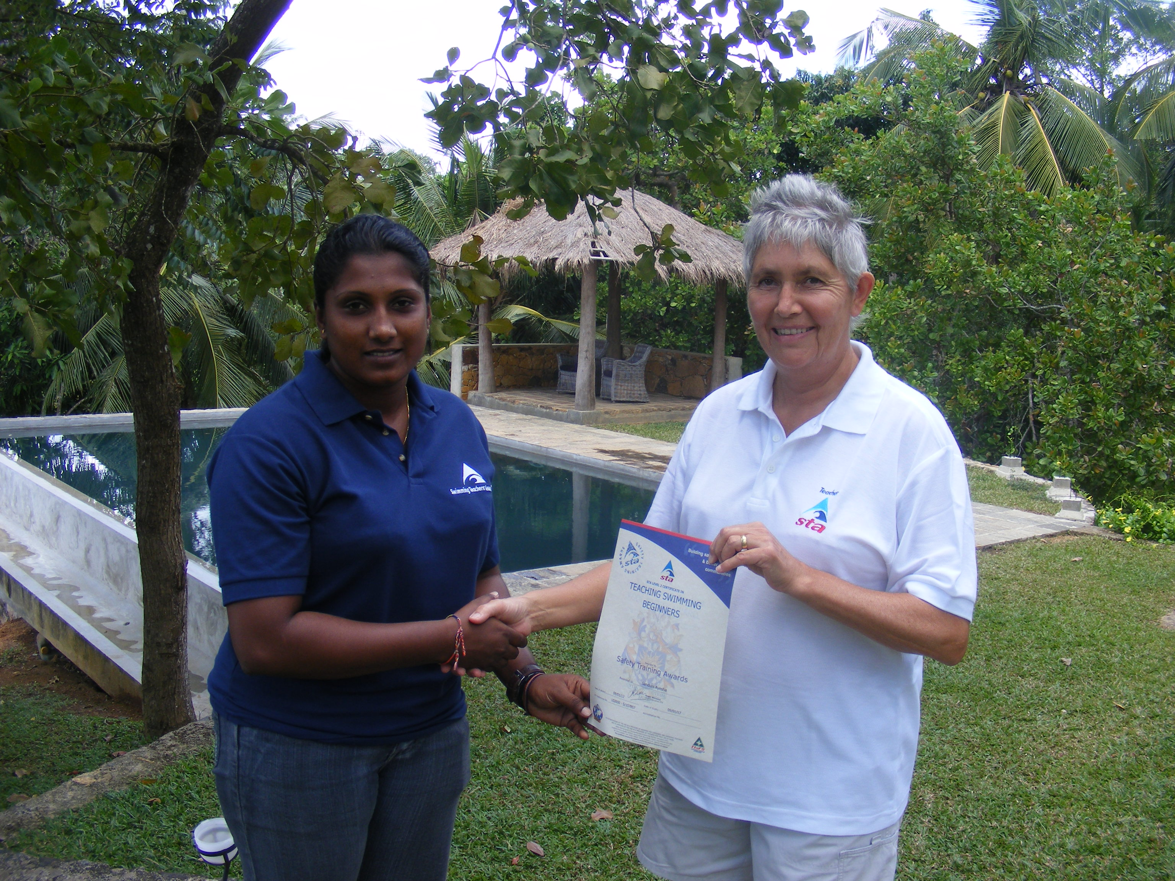

Congratulations to Sanduni, seen here accepting her UK STA
Beginner Teacher Certificate from Christina.

We are especially pleased to have Sanduni return down south to us for further formal STA training as a pre-cursor to taking up a unique post in the Middle East as a member of an all-girl team running a Ladies Only Beach just opening up in Dubai. Sanduni is very excited by this job and has ambitions to save up enough money to build her own swim school in her own village in Sri Lanka upon her return. We congratulate Sanduni on her fine achievement and look forward to hearing about her activities in Dubai.

Finally, it should be mentioned that there were more students on this STA course than the two mentioned thus far; the additional teachers have yet to build up more teaching hours before we can hand them their certificates. The reason for this that the adults we teach have had absolutely no previous experience in water and have only learned to swim a matter of months ago. Although they are now competent swimmers, they lack a whole swathe of aquatic experiences which western children start accumulating from about age four, from things as simple as picking up sticks and things from the deep end to games such as swimming underwater leap-frog. Taken together with all the water safety issues we take for granted in our culture, much of what we assume to be common aquatic knowledge still has to be learned by our teachers before we let them ‘go solo’. So there will be more news of more teachers to come.

Well done Dinusha. Well done Sanduni.

Christina Fonfe’

