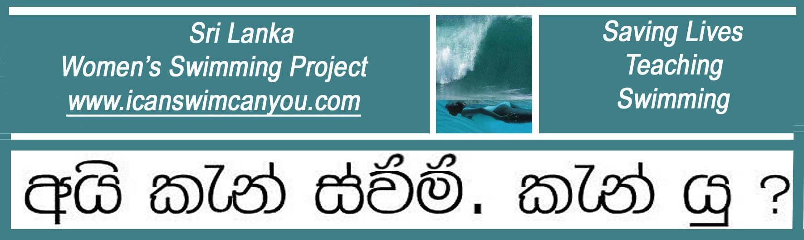
A United Kingdom Registered Charity No. 1129236 www.charity-commission.gov.uk/Showcharity/

March 2012 Latest News

Sri Lanka’s First Drowning Prevention Conference Held Under the Auspices of the Ministry of Health.

The swimming teaching community, involved as it is, in teaching swimming as a drowning reduction measure rather than as a competitive sporting activity, has long joked that if drowning deaths were looked at through a medical rather than a sporting perspective, it would have declared an epidemic and dealt with as a public health preventive measure. We were therefore delighted and honored to be invited by Doctor Diana Samarakkody, the National Program Manager for Injury Prevention & Control, to take part in a pilot investigation into drowning deaths in Sri Lanka .

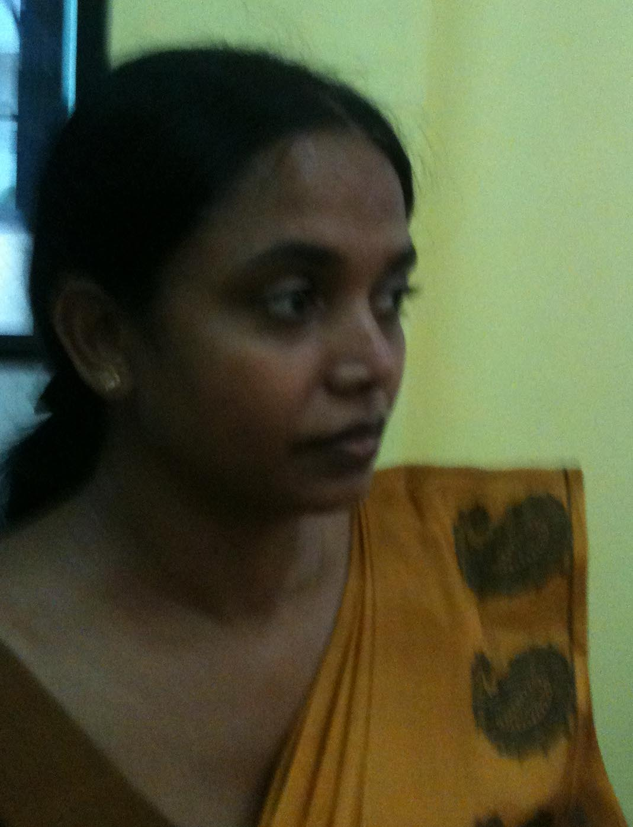
Driving Force: Dr Diana Samarakkody
The aim of the Inaugural Meeting was to identify all the interest groups in Sri Lanka who were involved with teaching swimming and explore the possibility of standardizing initial training to a common level of minimum skill and educational measures needed to reduce drowning in Sri Lanka.

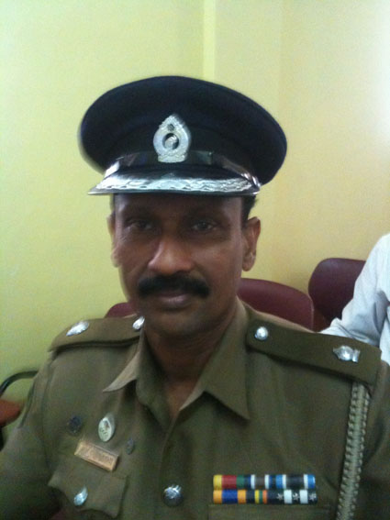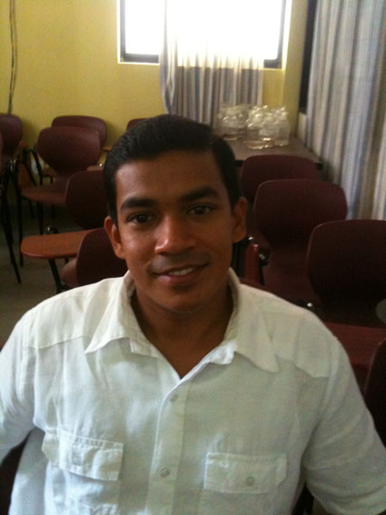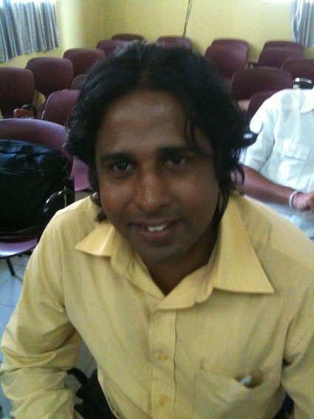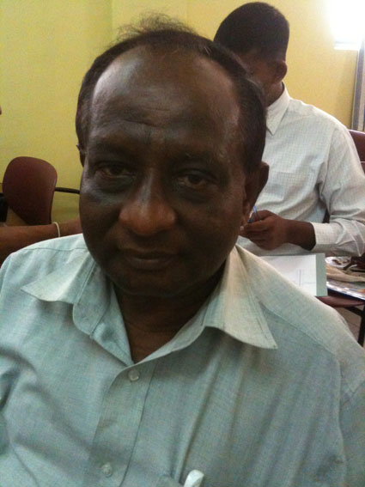
Some of the Drowning Prevention Talent Across a Wide Spectrum of Aquatic Interest
It was clear from early in the proceedings that there is currently no standardized procedure or single focal point for the collection and upward reporting of drowning statistics as there are for diseases such a dengue. Where death is consequential to water inhalation, such as pneumonia, the initial cause of the chain of events leading to death is often lost. In rural or coastal communities, drownings information reported to the police or other officials may not necessarily be easily accessible to other government departments. We look forward to the next meeting where each organization will present what it does in the drowning prevention field and see how we can all work together. Christina Fonfe’

