tw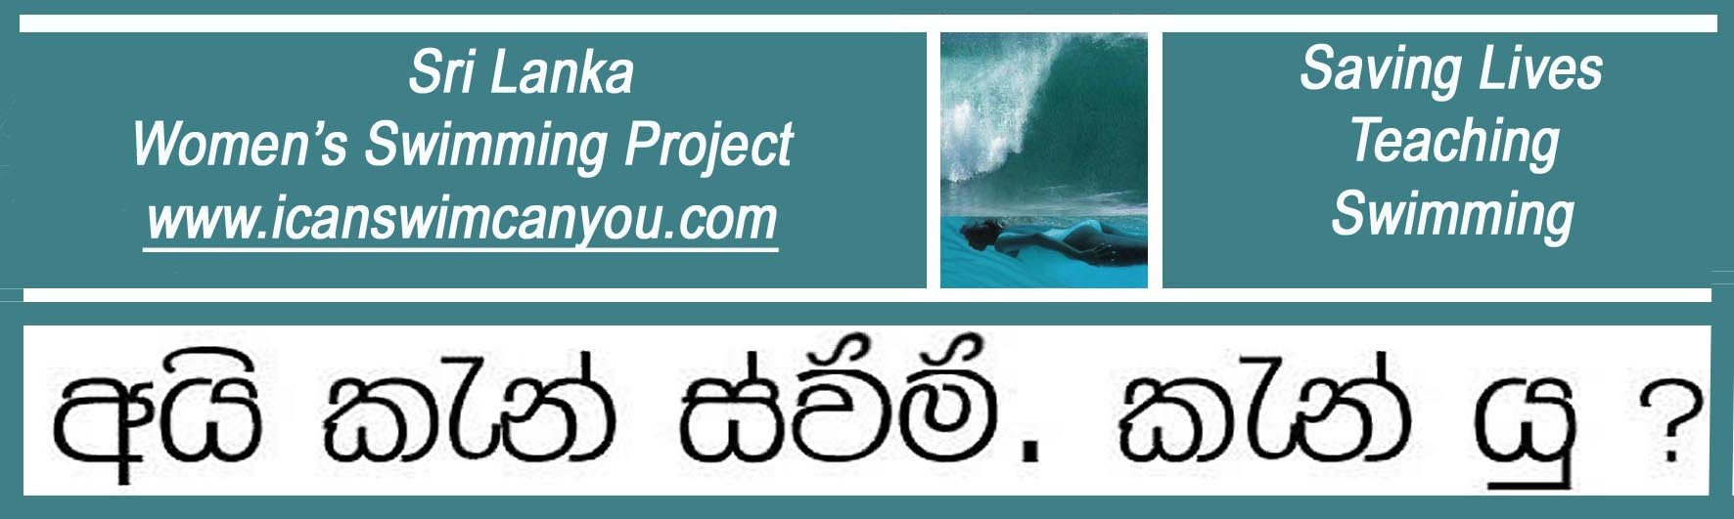
A United Kingdom Registered Charity No. 1129236 www.charity-commission.gov.uk

12 June 2012 Latest News

Deputy High Commissioner Visits Sri Lanka Women’s Swimming Project

The Deputy British High Commissioner to Sri Lanka, Mr Robbie Bulloch, paid a visit to the Ahangama headquarters of the Sri Lanka Women’s Swimming Project and presented internationally recognized Swimming Teaching Certificates to two of the Project’s newly qualified teachers, Indu Wickramanayake and Sumudu Maramabage, both of Habaraduwa. The young women are cousins and neighbours living on Koggala Lake. As a young girl, Sumudu had taught herself to swim in the lake; Indu, on the other hand, was a complete non-swimmer until she joined the Project. Heeding the parting words of her professor at university, who said that upon completion of her degree, if ever she should have the opportunity to learn to swim, she should do so, Indu and her cousin signed up with the Project a year ago and have been involved in teaching swimming ever since. Sumudu is probably the sleekest streamlined swimmer the Project has seen, while Indu is a fine translator and a co-author of the Project’s Sinhala-English learn-to-swim manual, appropriately titled “Can’t Swim? Don’t Drown! Learn to Float and Breathe, then Swim”.

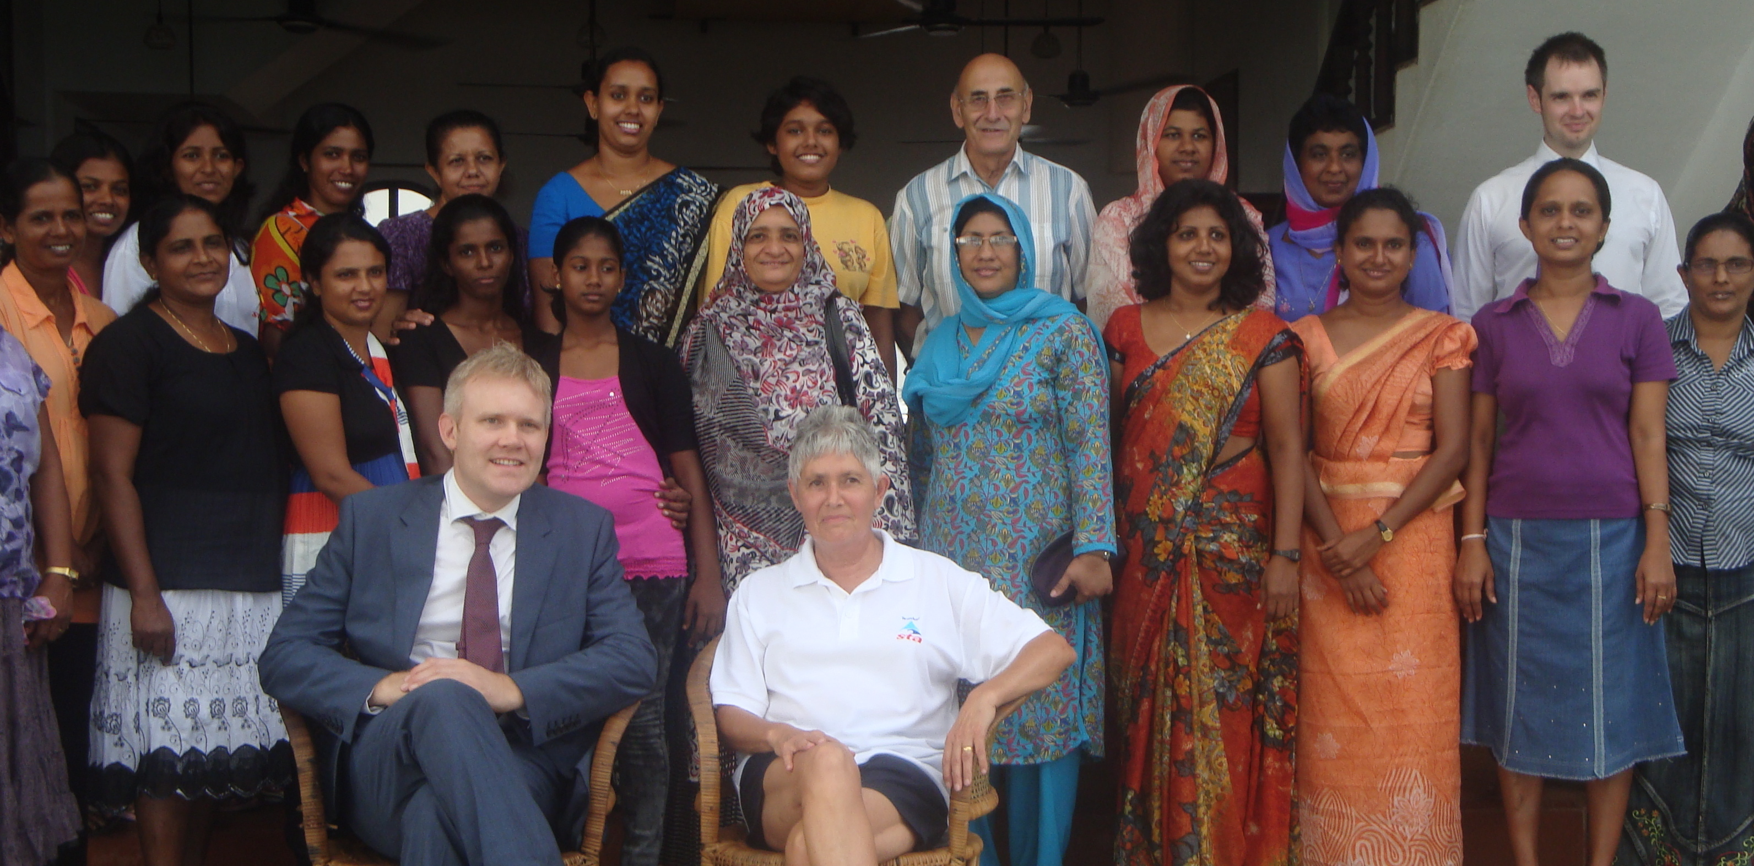

Three generations of women prove to Deputy High Commissioner Robbie Bulloch
that anyone can be taught to swim in Christina Fonfe’s Sri Lanka Women’s Swimming Project

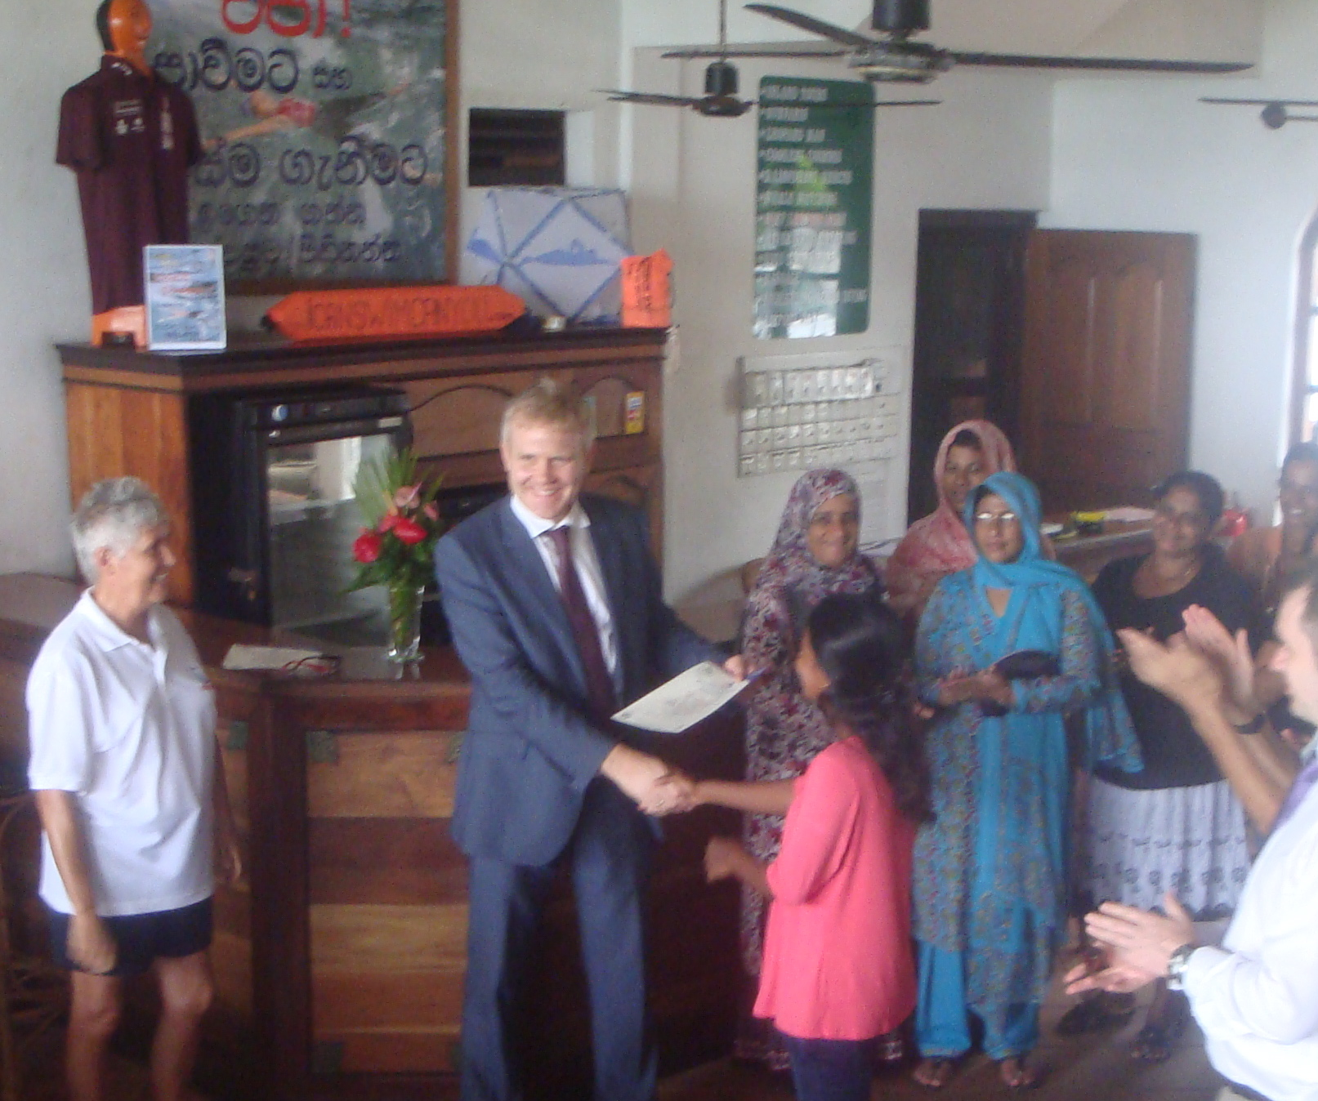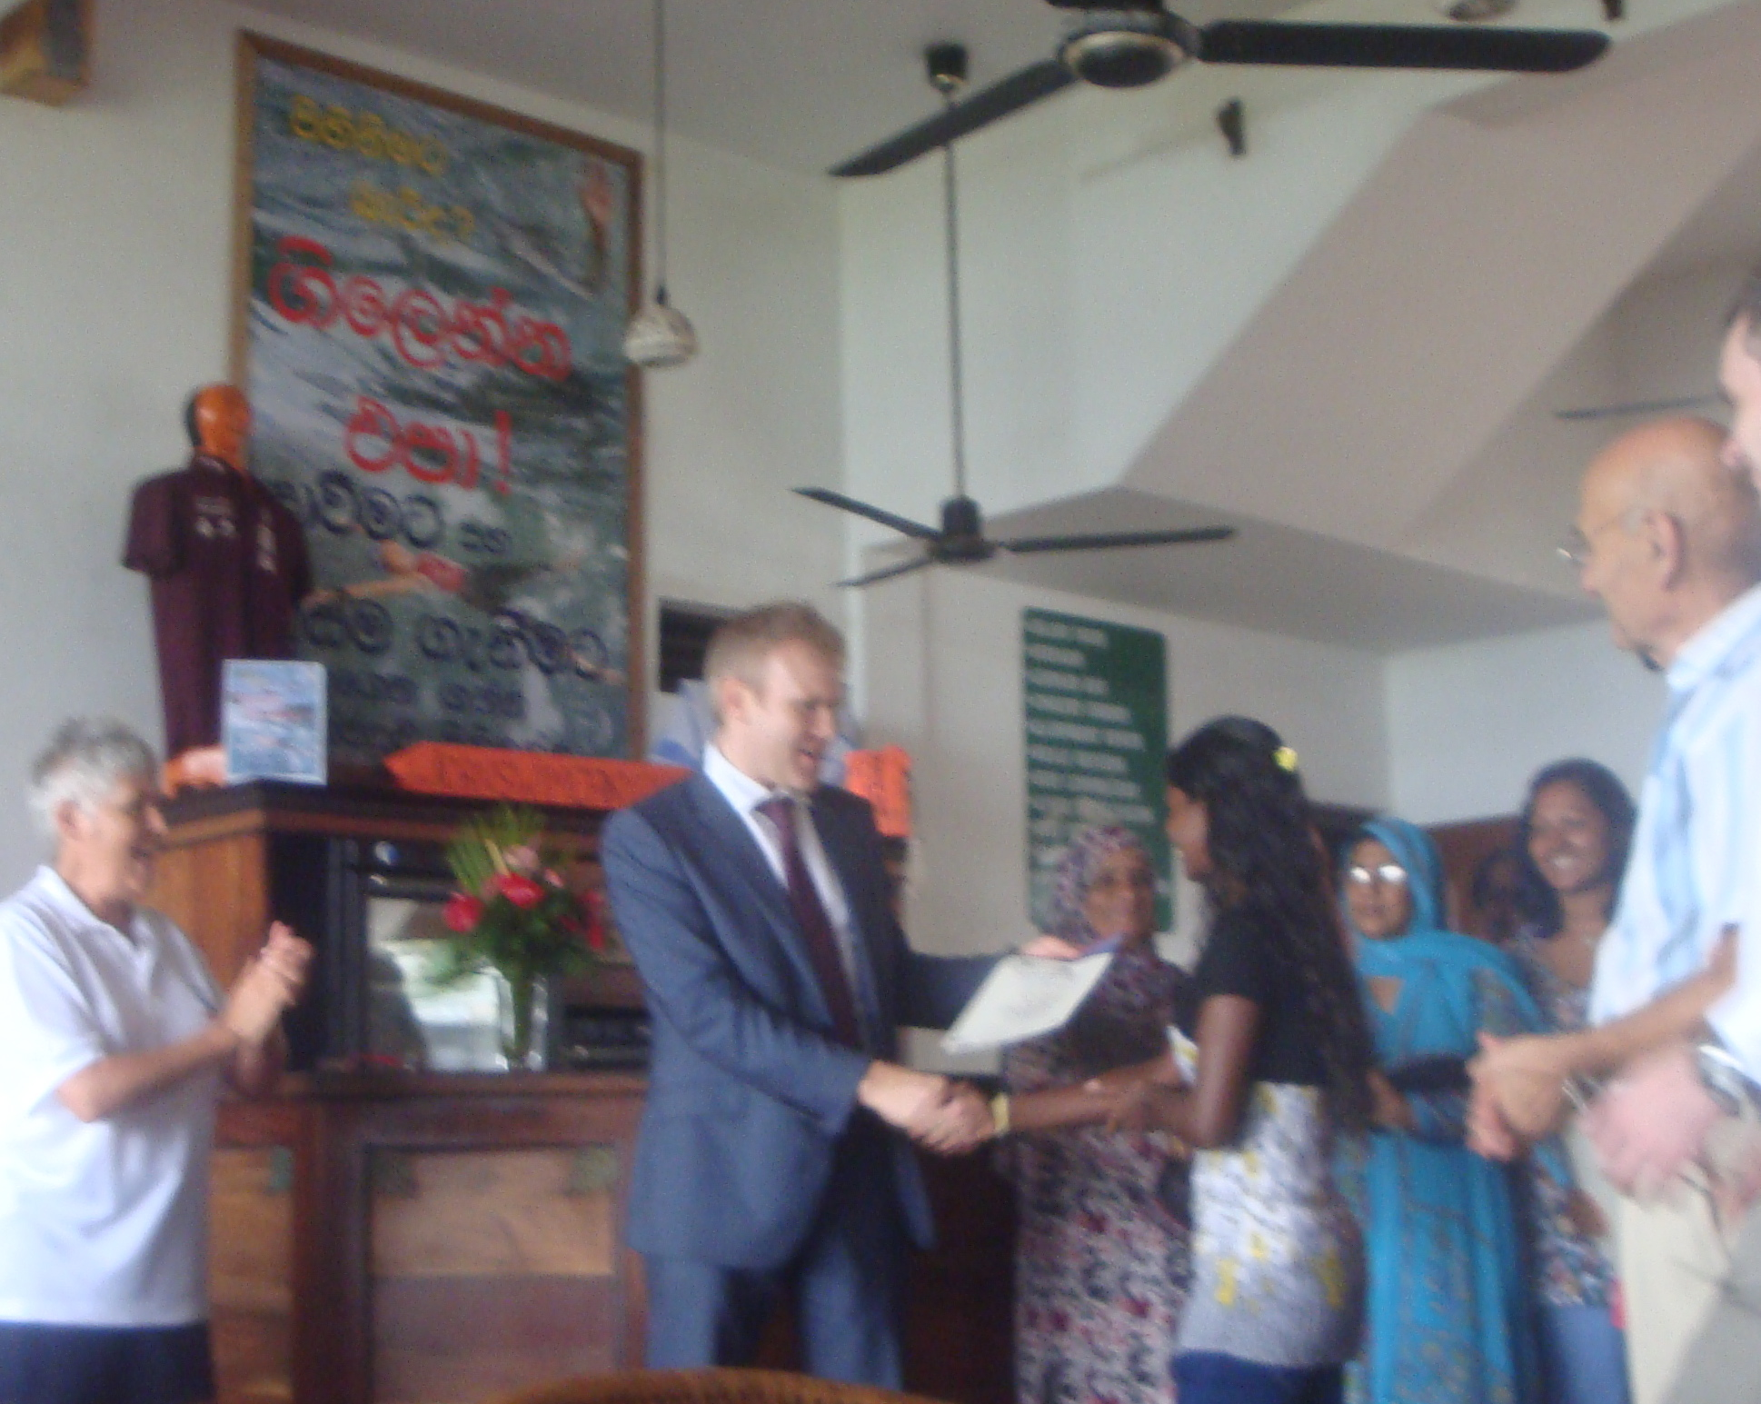
Indu (left) and Sumudu (right) receive their certificates from Deputy High Commissioner Bulloch

Following the presentation of the Teaching Certificates, the Deputy High Commissioner then presented the Project’s pioneering “I Can Swim” Certificates to a number of women who have learned to swim in maturity. These ladies constitute the core of the Project’s target population on the premise that if a mother can swim, she will pass the knowledge on to her children and probably grandchildren. The Project, incidentally, only declares that a student ‘can swim’ when they can jump into deep water, submerge totally, recover to the surface and float on their backs to breathe for 10 minutes, then swim figures of eight to cover 100 metres without touching any pool side or bottom and, finally, climb out unaided, over a 30 cm ledge. This is no mean feat and we congratulate our graduates on their magnificent achievements.

Christina Fonfe’

