Latest News

Friday 6 June 2008

From: Christina Fonfe

Received by: Email.

More people drown than die of HIV AIDS

Sadly, the secluded little swimming pool in the Palm Forest coconut plantation in Weligama, where 800 women have been taught to swim over the last three years, is currently out of use. The property has been sold and the old buildings are being demolished to make way for new villas and, hopefully, a new pool.

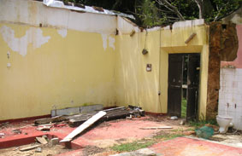
Goodbye to Palm Forest Plantation Bungalow

With the Plantation now a building site, it is simply not possible to use the old pool and so, in the interim, we have been compelled to operate at a low key, using our two local Student Teachers. Umesha and Dinusha have both continued to teach swimming between their studies at rented hotel pools during the tourist low season and have kept the Project ticking over.

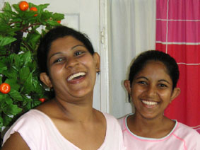
Umesha and Dinusha de Silva

In April, I returned to Sri Lanka and was made very welcome at the Insight Hotel, formerly known as Club Lanka, in the beach village of Ahangama, just north of Weligama. Here we are currently teaching about 100 women from the village at a cost of a hundred rupees (about £0.45p) per person per day. This pool is considerably larger than the one at Palm Forest, with a proper deep end where we can really advance our swimmers properly, to do such things as treading water, tumble turns and swimming in water clearly out of their depth – always a scary experience for new swimmers.

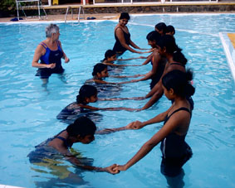
Project Founder Christina introduces new women to the Insight Hotel Pool

The really good news for the Women’s Swimming Project, however, is that a new group of swimming teachers are beginning to emerge out of our training program. For example, Sunita, the wife of our caretaker at Palm Forest has, through diligent observation and enthusiastic voluntary work, become an excellent Total Immersion student and is doing a tremendous job teaching individual women the basics of the first few lessons of the Total Immersion “Happy Laps” method of getting adults to swim without ever using a floating aid.

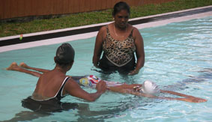
Sunita supervises a Pencil Float in the Insight Hotel Pool

In addition to advancing our home-grown swimmers into teachers, I have been able to recruit a few new teachers to the Project. First, there is a delightful young lady, Samathika, whom I would especially like to introduce you to. Samathika taught herself to swim in the local lake and, after just a little coaching from me, now swims a fine front crawl; she has just started giving Total Immersion instruction to our first time swimmers at the Insight Pool.

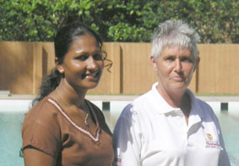
Self-taught swimming teacher Samathika with Chris

Another Project old hand, Prabath, who has been my rental car driver whenever I am in Sri Lanka, has doubled variously as bodyguard, interpreter, document translator and has even ‘allowed’ himself to be taught by my three Student Swimming Teachers, Umesha, Dinusha and Sanduni. He is currently working towards his student swimming teacher qualification as well as his pool maintenance foundation qualification and will become the Women’s Swimming Project’s first male teacher, having also been our first male student.

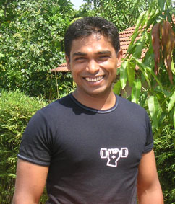
Prabath, currently the Women’s Swimming Project’s only man

After three years of fund raising, planning and finally building, the west coast’s long awaited new community pool in Galle is shortly due to open on the 29th June. More news will follow once the Official Opening has taken place and I can then reveal the full and proper name of the swimming pool. However, we are allowed to say that our women are already in the water there and some of them are even swimming! One day each week initially has been set aside specially for women only to learn to swim and be safe in water in this pool. Throughout my time in Sri Lanka, it has always been my policy only to train local women to hold positions within the Project. To this end, I have just managed to recruit Damika, a well known local swimming personality, who is also the National Open Water Swimming Champion in Sri Lanka. Damika will act as my senior female coach, initially in Galle, and will be assisted by Samathika.

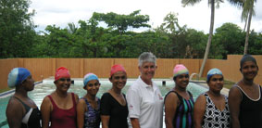
Project’s new coach Damika, far left, with the Convent Ladies

Finally, another pool has been built in the village of Seenigama, where over a thousand people were swept to their deaths inside the Matara Express train by the tsunami. The building of the pool was funded by singer Bryan Adams generously auctioning off one of his guitars. The new pool, known as The Bryan Adams Pool, forms part of a ‘Centre for Excellence’ under the umbrella of the Sri Lankan philanthropist Kushil Gunesekera’s Foundation of Goodness and I am very hopeful of negotiating the necessary arrangements to have women and teenage girls taught swimming there as well.

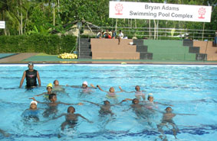
What a wonderful gift – The Bryan Adams Pool in Seenigama

Whilst it is marvellous to have all these women learning to swim in new pools, they are well north of my target area of Weligama, My original aim remains to address the poorer coastal and rural communities in the far south and ensure that I can teach as many as people as I can to be safe in water. There remains the urgent need to build a modest community pool somewhere between Weligama and Matara.

This leads me to draw your attention to just how important learning to swim is. In recent months, we have become aware from a World Health Organisation study that indicates more people die from drowning than die from HIV AIDS . This fact has really shocked me, as the drowning statistics gathered do not even include those of the Dec2004 tsunami.

We desperately need a community pool and need to put women first in the program because, being the mothers and elder sisters of those most at risk from drowning, they are far more likely to teach their own in their own communities than us. On this basis, I look forward to meeting any sponsor, out there, who might be willing to bring a life-saving swimming pool to the delightful but absolutely poor coastal rural community of Weligama.

Wanted: 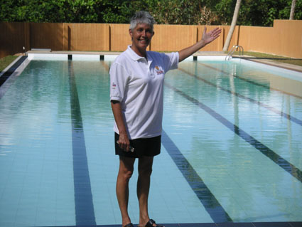 A pool like this for Weligama!

MAKE DROWNING LESS OF A KILLER THAN AIDS OR WAR

