INCLUDEPICTURE "http://www.icanswimcanyou.com/images/top_banner.jpg" \* MERGEFORMATINET 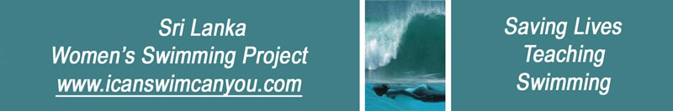
Home Page
I can swim. Can you?
Latest Project News
Related Links
Press Cuttings
Donors and Supporters

I Can Swim Can You - Overview

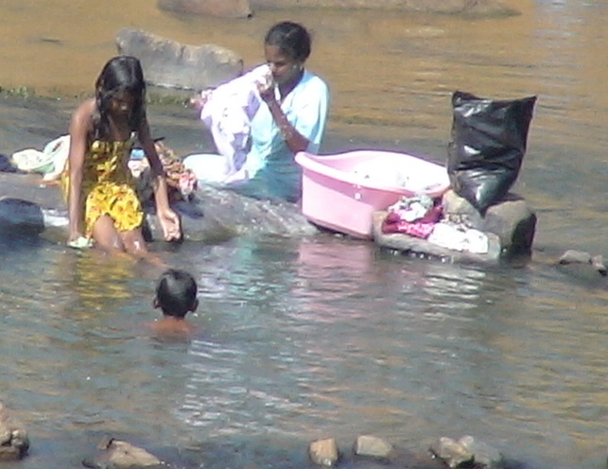
In poor communities, the boys swim while the girls stay fully clothed and only watch

The Sri Lanka Women’s Swimming Project, motto: I can swim. Can you? was founded by Christina Fonfe after the 2004 tsunami, where 80% of those who drowned were women and children. Even now, up to 3 people every day still continue to drown on the beaches, lakes and rivers of Sri Lanka. Indeed, more Sri Lankans drown than die of dengue fever. Worldwide, a million people drown every year. Drowning is a serious killer of global epidemic proportions.

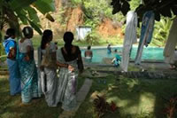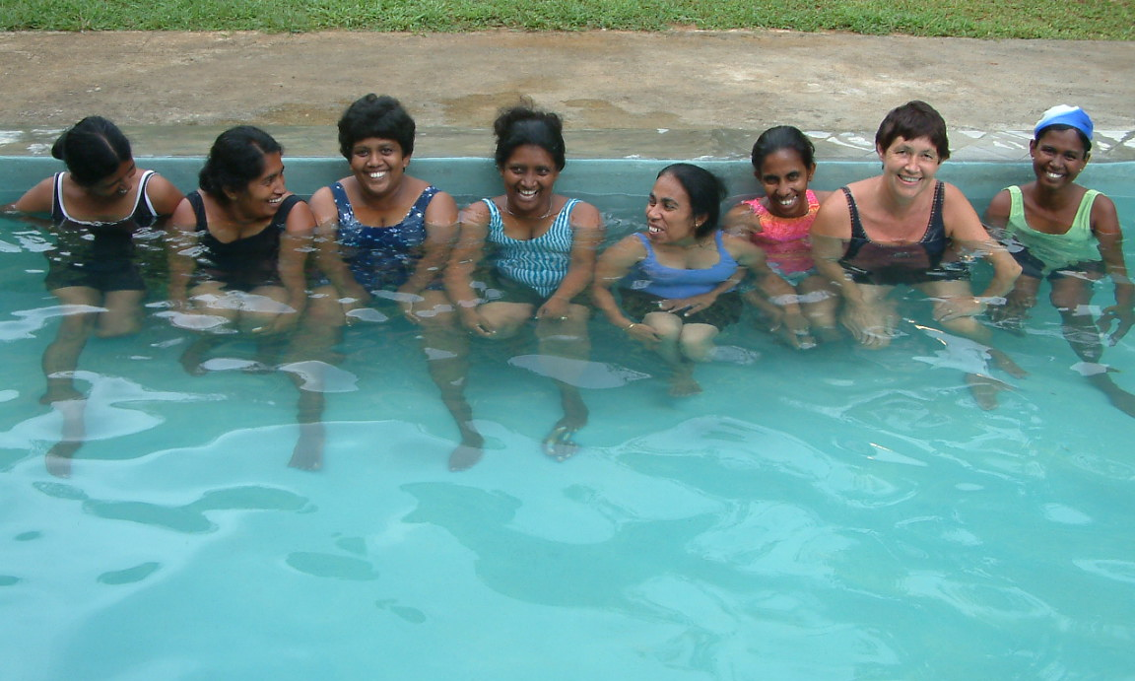
Taking two big steps: First from a Sari into a Swimsuit and then, Secondly, into a Swimming Pool

In poorer rural, coastal and even city environments, females are chaperoned outside the home. These women wash fully clothed at the well or communal washing place. They have little experience of entering more than knee-deep water. Tight, wrap-round dresses and full body covering hinders agility. Almost without exception, when presented with a drowning crisis, women are unable either to rescue a child in difficulty in the water or to save themselves from drowning. People do not drown because they cannot swim; they drown because they cannot breathe. The solution: simply learn to Float and Breathe.
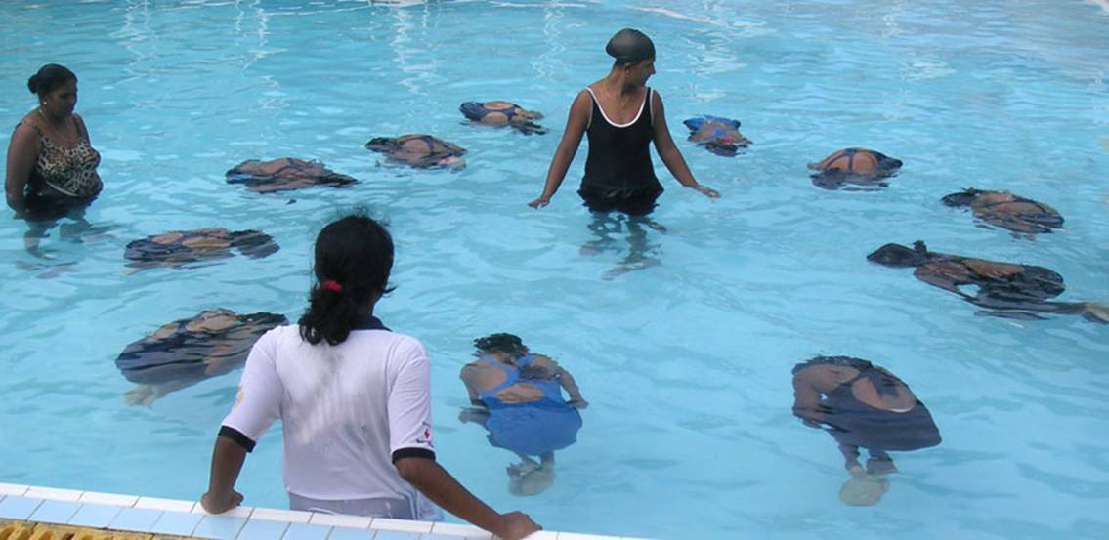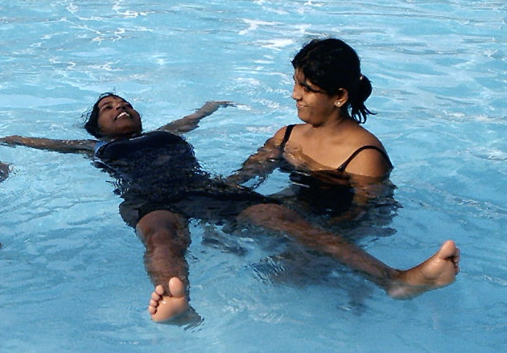
FLOAT & BREATHE is easy when you relax to let the water hold you up.

Our vision is to give every individual the greatest chance of survival in water and make everyone safe near water. The Women’s Swimming Project aims to save lives by giving women and teenage girls free lessons to FLOAT and BREATHE and THEN SWIM. Once the women and girls have learned to swim effortlessly and safely so that they, in turn, can teach their own children and remaining non-swimmers in the community how to float, breathe and swim as easily as they can walk, thus making Sri Lanka a safer place.
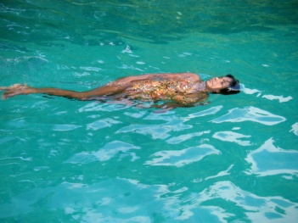
After a few lessons, our women can swim as smoothly
through the water as this and breathing easily as they go.

Women and teenage girls who learn to swim and have leadership qualities are trained as Community Swimming Teachers to international standards and can enjoy the micro-economic benefit of a career in teaching swimming. The most able villagers are now also able to enter swimming competitions with an Olympic gold medal in mind. And everybody is fitter, healthier, happier and safer for having learned to swim.
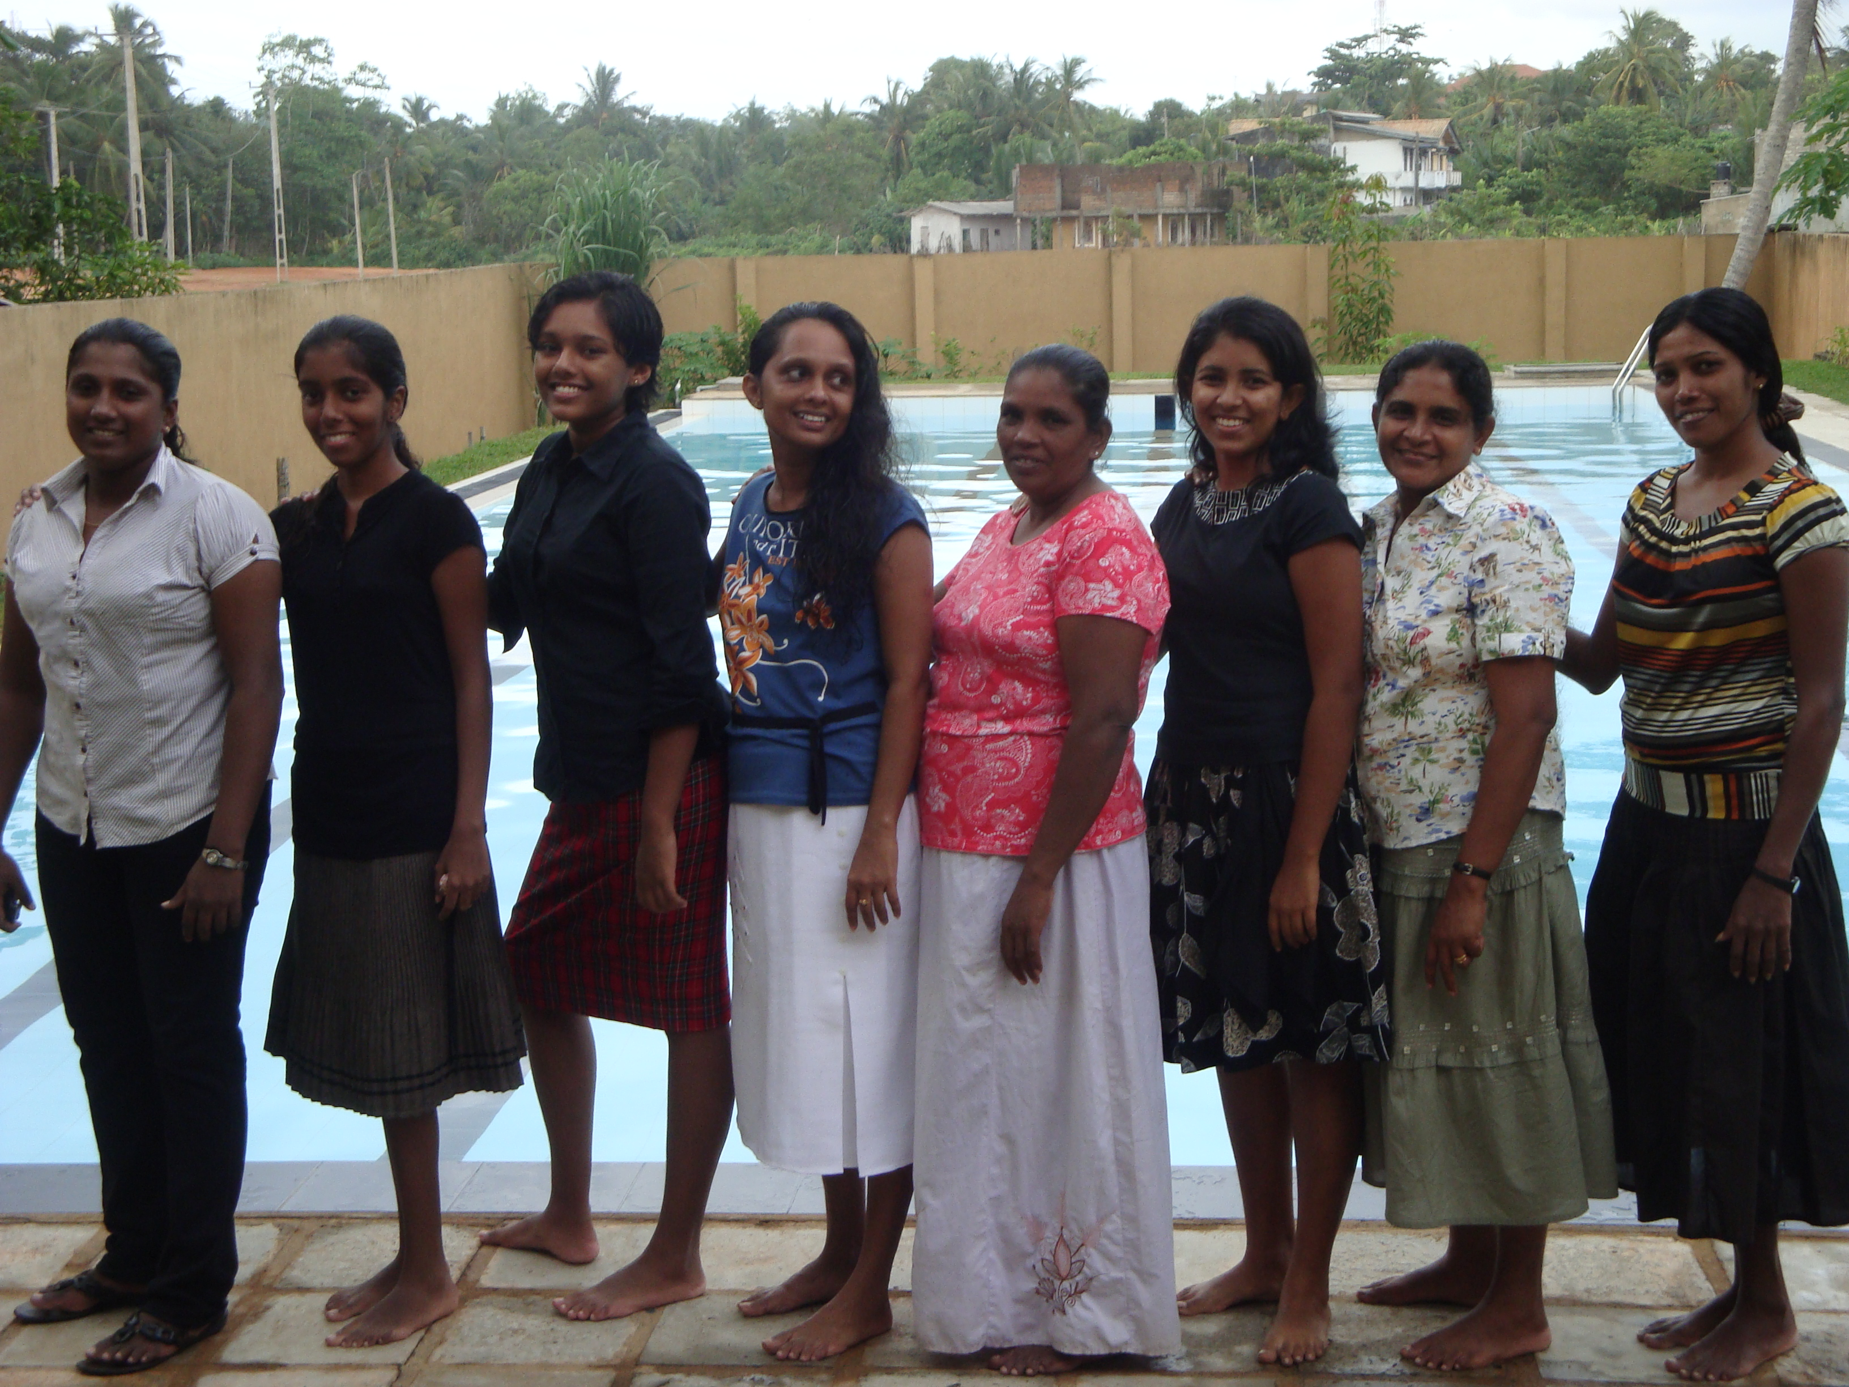
Our happy swimming teachers come from every walk of life.

We are a small UK Registered Charity No 1129236 with no paid employees.

Donations support our local swimming teachers directly.
If you would like to donate or help, please send an email to at:

icanswimcanyou@mac.com
INCLUDEPICTURE "http://www.icanswimcanyou.com/images/Total_Immersion_Logo.jpg" \* MERGEFORMATINET  | INCLUDEPICTURE "http://www.icanswimcanyou.com/images/IFSTA_logo.jpg" \* MERGEFORMATINET  |  |  | INCLUDEPICTURE "http://www.icanswimcanyou.com/images/irish.jpg" \* MERGEFORMATINET 

