Latest News
Saturdday 30 April 2011
From: Mike Fonfe
Received by: Email
Sri Lanka Women’s Swimming Project
Fires up in New Home
The Women’s Swimming Project is now in its sixth year of operation since the tsunami and has not missed a day of teaching swimming, despite the many difficulties encountered. The most critical of these has been to find suitable teaching pools. The Project has just secured the use of a private pool on Koggala Lake, a large lagoon in the small, coastal, rural town of Habaraduwa, south of Galle, in the Southern Province of Sri Lanka. This is in addition to the on-going Women Only Swimming Day the Project already runs in Galle. Recruiting non-swimmers in Habaraduwa has begun, with visits to schools and businesses to persuade women and teenage girls to swim.
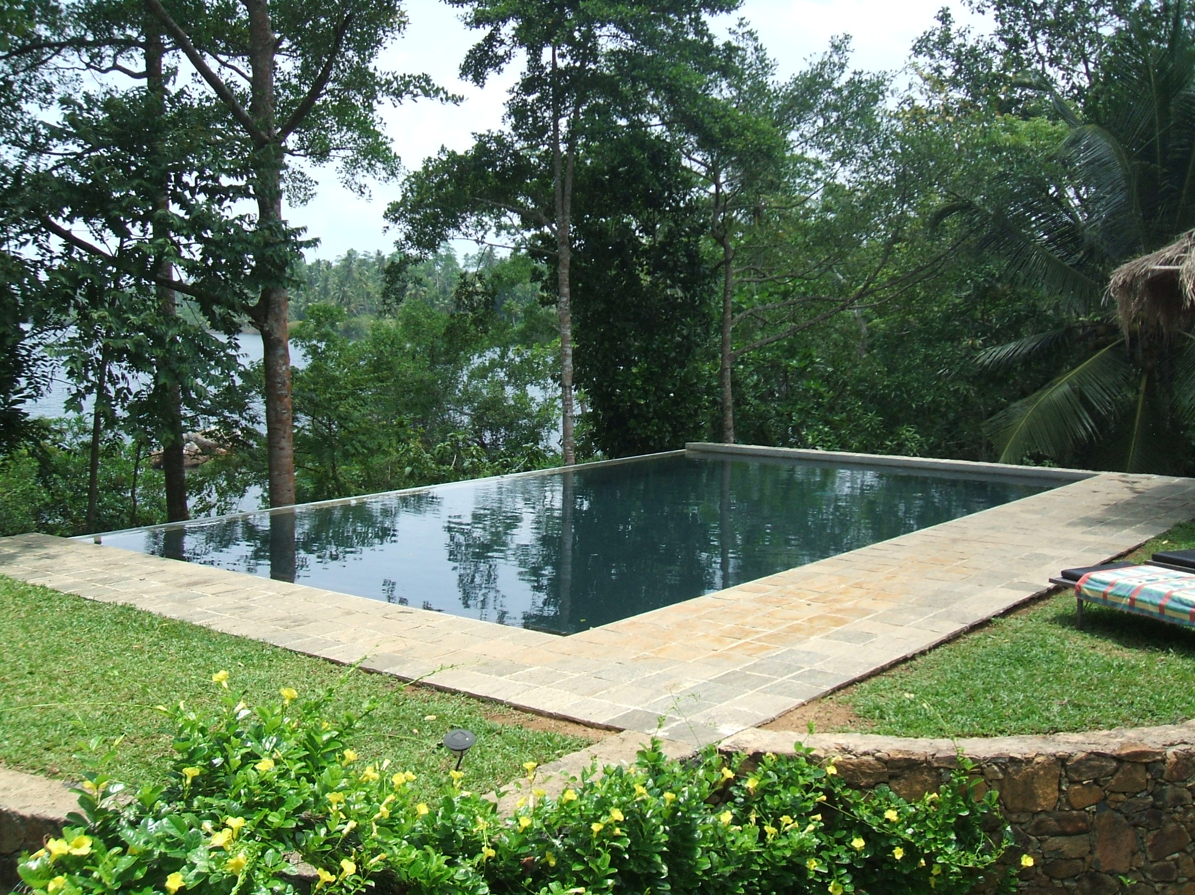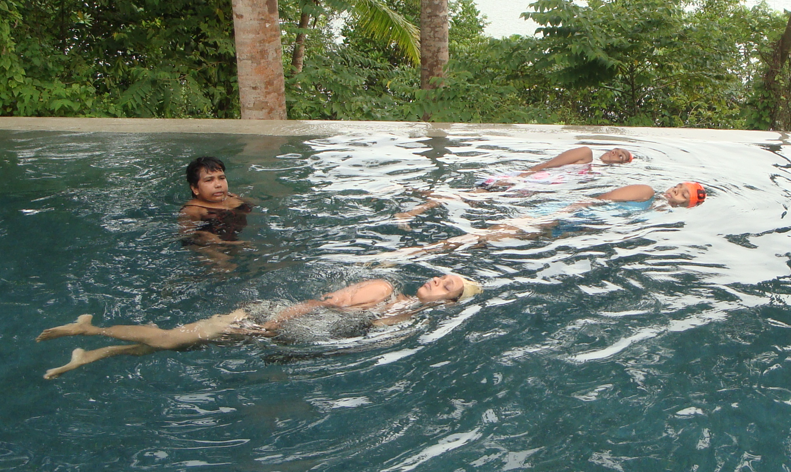
The Project’s small but secluded private pool Privacy provides this trio of women with the privacy they need as they practice swimming and breathing on their sides.
Habaraduwa has all the typical drowning risks of a rural coastal community. The rural part is a mix of coconut groves, rice paddies and mangroves; the coastal part is fronted by beaches and reefs with some tricky currents and is backed by Koggala Lagoon, complete with crocodiles and aquatic monitor lizards.
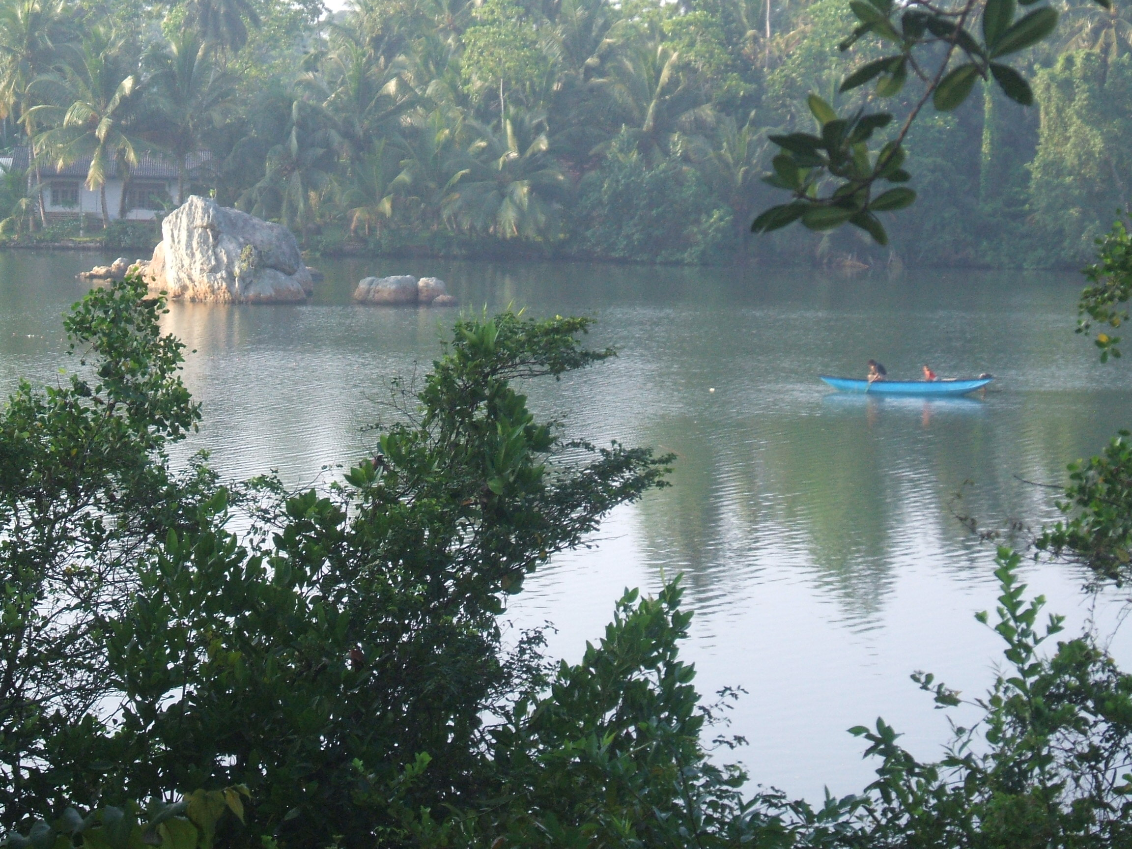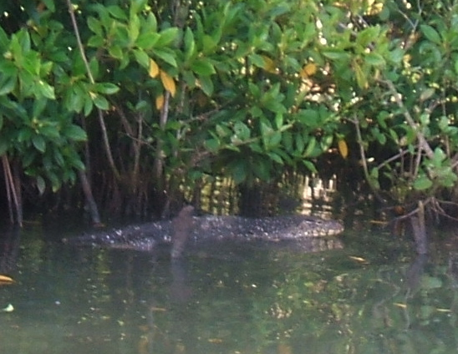
Koggala Lagoon looks serene but has aquatic lizards the size of a crocodile.
The Project pool is located in the middle of the community, yet is totally secluded from casual view, giving the shy women the privacy they need to concentrate entirely on learning to swim. The free classes are also used to advance existing teachers and bring in new ones. New swimmers are given a donated new swimsuit and are asked to bring a friend to their next lesson. Most women coming have never ever been in a swimming pool, so the first task is to introduce float-and-breathe, the single most essential life saving skill they are required to learn.

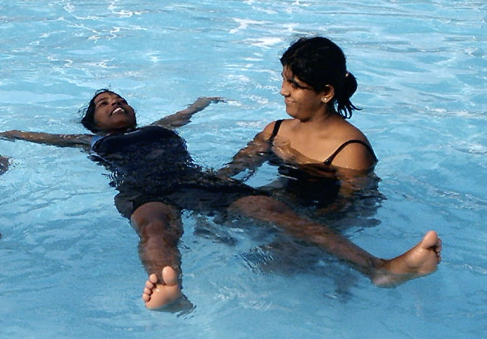
Teacher Umesha demands perfect balance and total relaxation to hold that face-up float-and-breathe position that is the core survival skill of our Project indefinitely.
Very soon, within a few lessons, the girls are able to maintain a float-and-breathe position for an indefinitely long period. They are then introduced to streamlined propulsion and learn to swim on their backs. When they have achieved perfect balance, they then learn Terry Laughlin’s Total ImmersionTM drills to streamline even further by swimming on their sides, roll to do bilateral breathing and learn take their first strokes. At no time are they allowed to advance their swimming skills ahead of their breath control, so we always have swimmers who can breathe properly from the very start. The reward is that our girls develop a great streamlined style, slicing gracefully through the water just like a fish, without any splashing, and breathing safely all the way.
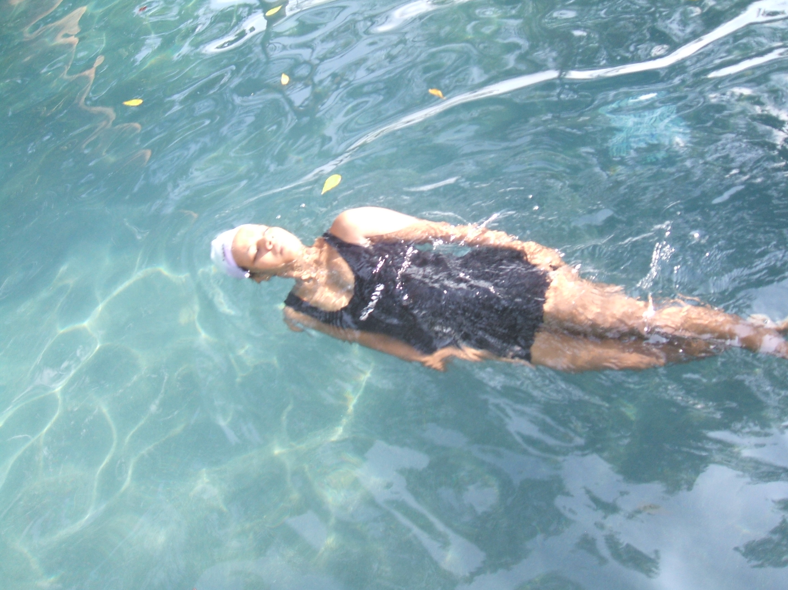
A beautiful bow-wave marks Indu’s smooth, fish-like passage, swimming on her side with minimal propulsion effort and maximum streamlining through the water.
SRI LANKA WOMEN’S SWIMMING PROJECT UK CHARITY NO 1129236
Click to download printable Microsoft Word version
Back...

